**1. Introduction**

**1.1 Problem Statement**

Our project is to develop a website for Archana Computers which can calculate attendance of the students. The main aim is that the admin should get attendance in ms excel format. There should be different logins for teacher , assistant and admin. Teacher should be able to fill the daily attendance of the students and that attendance should reflect into admin dashboard.

**1.2Problem description**

Our project is to design a website for Archana computers that can calculate attendance of the students. The website should contain three modules. The modules will be admin, assistant and teacher. Admin should be able to get overall attendance report of the student and would be able to get monthly attendance in excel sheet. Admin should be able to assign login credentials to teacher as well as assistant. Also admin should have rights to add and delete teacher and assistant.

**1.3Requirement Specification**

**1.1 Website functions and overview**

Generally in different institutes attendance is calculated but cannot be converted into excel sheet. So, our main aim is to convert attendance into excel sheet. The authority to convert attendance into excel sheet will be given to admin only. Totally there will be three modules. The modules are admin, assistant and teacher. Admin module will be having rights to add, delete teacher and assistant and assign login credentials. Also admin will be able to see the overall attendance. Admin will be able to get monthly attendance in excel sheet. The teacher module will login by using login credentials assigned by admin. After login, teacher will be directed to attendance page. Teacher has to fill the attendance and submit it. The assistant module will login by using login credentials provided by admin and will do student registration by filling the form.

**1.2 User Characteristics**

The users of the website are the teachers, assistant who are currently working there. As the admin has the right to add and delete teacher and assistant so only registered teacher and assistant can access it.

**1.3 General Constraints**

The website can run on any system. It can also run on mobiles, tablets, etc.

**1.4 External Interface Requirements**

User Interface : The users that are admin, assistant and teacher have to click on the module name mentioned on homepage. After clicking they have to login by using their email and password . Teacher and assistant have to login by using their email and password assigned by admin.

**1.5 Performance Constraints**

For Admin module, when teacher fills the attendance, it will directly reflect to admin without refreshing a page. Automatically all the details will be updated lively on admin page.

**2**. **Literature Survey**

**2.1.1) Online Blood Donor Life Saving Application**

Blood Donation Management System is a web enabled and mobile-based application to maintain day to day transactions in a blood bank. This application is to create an e-Information about the donor and organization that are related to donating the blood. This software help to register all the donors, Blood collection details, blood issued details etc .When registration is completed, a user becomes a donor who will be able to open an account providing fundamental information with email ID and Password.

Emergency situations, such as accidents, create an immediate, critical need for specific blood type. In addition to emergency requirements, advances in medicine have increased the need for blood in many on-going treatments and elective surgeries. Despite increasing requirements for blood, only about 5% of the Indian population donates blood.

* + 1. **Helps a lot in Emergency Situations**

Emergency situations, such as accidents, create an immediate, critical need for specific blood type. In addition to emergency requirements, advances in medicine have increased the need for blood in many on-going treatments and elective surgeries. Despite increasing requirements for blood, only about 5% of the Indian population donates blood

* + 1. **Online Blood Bank**

Blood is a saver of all existing lives in case of emergency needs. The task of blood bank is to receive blood from various donors, to monitor the blood groups database and to send the required blood during the need to the hospital in case of emergencies. The problem is not insufficient number of donors, but finding a willing donor at the right time. We want to build a network of people who can help each other during an emergency. This application timely updates the information regarding the donors where the administrator accesses the whole information about blood bank management system. Donor will be prompted to enter an individual's details, like name, phone number, and blood group. In the urgent time of a blood requirement, you can quickly check for blood banks or hospitals matching a particular or related blood group and reach out to them through the App. Blood bank App provides list of blood banks in your area. A large number of blood donors are attracted using an Android application. Since almost everyone carries a mobile phone with him, it ensures instant location tracking and communication. Only a registered person, with willingness to donate blood, will be able to access the service. In this application we are using the GPS technology that will be used to trace the way to the blood bank. The user will get the route to reach the desired location and he won't have to ask manually, therefore time can be saved.

**7. System Requirement**

**7.1 Hardware requirements**

Personal computer with, I5 Intel core processor, 1GB RAM

**7.2Software requirements**

Front end: HTML, CSS, Javascript, Bootstrap.

Back end: Database- MySQL, PHP PDO(PHP EXTENSION)

Tool: Brackets, XAMPP server

**8. Snapshot**

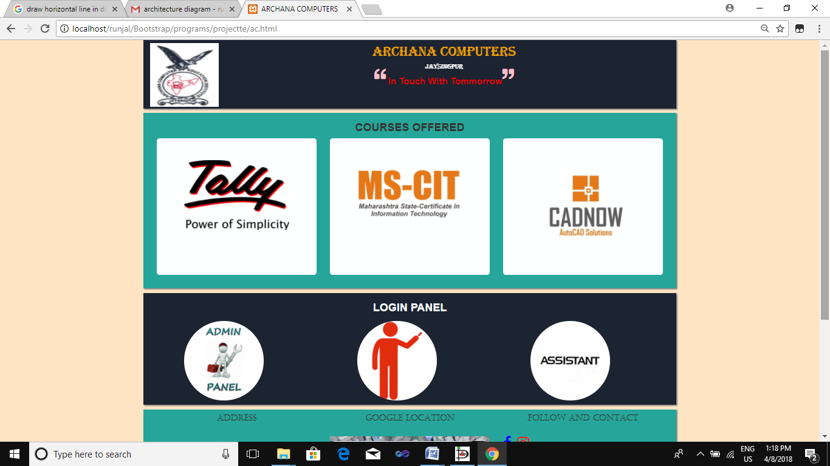

Fig a Homepage

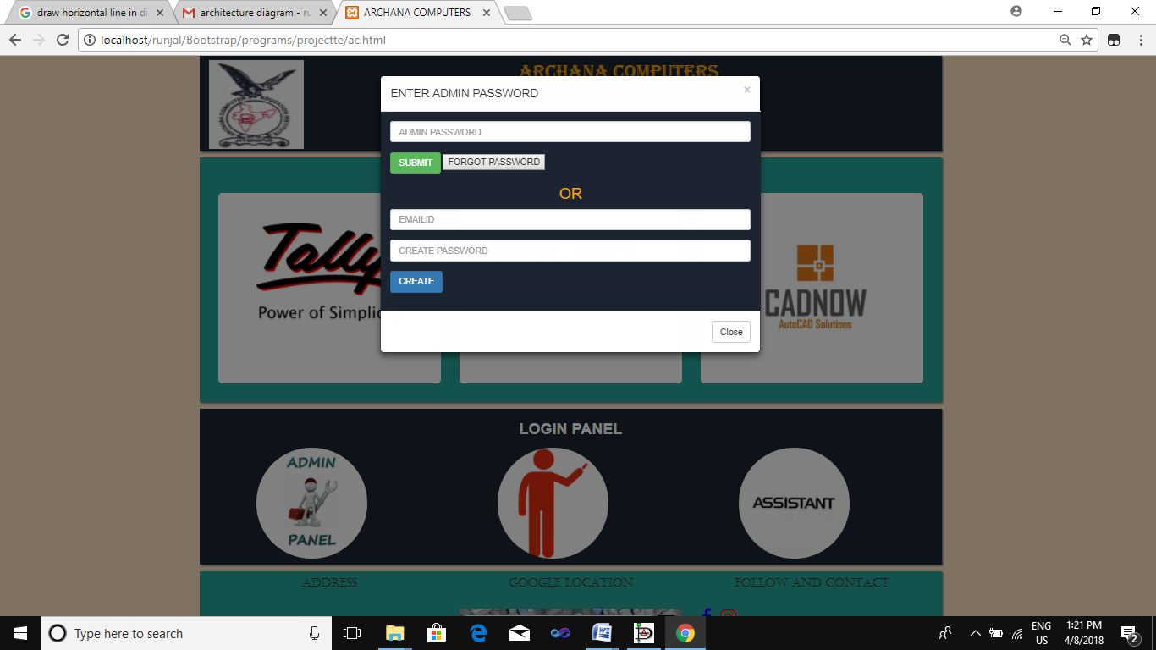

Fig.d:Admin Login Popup

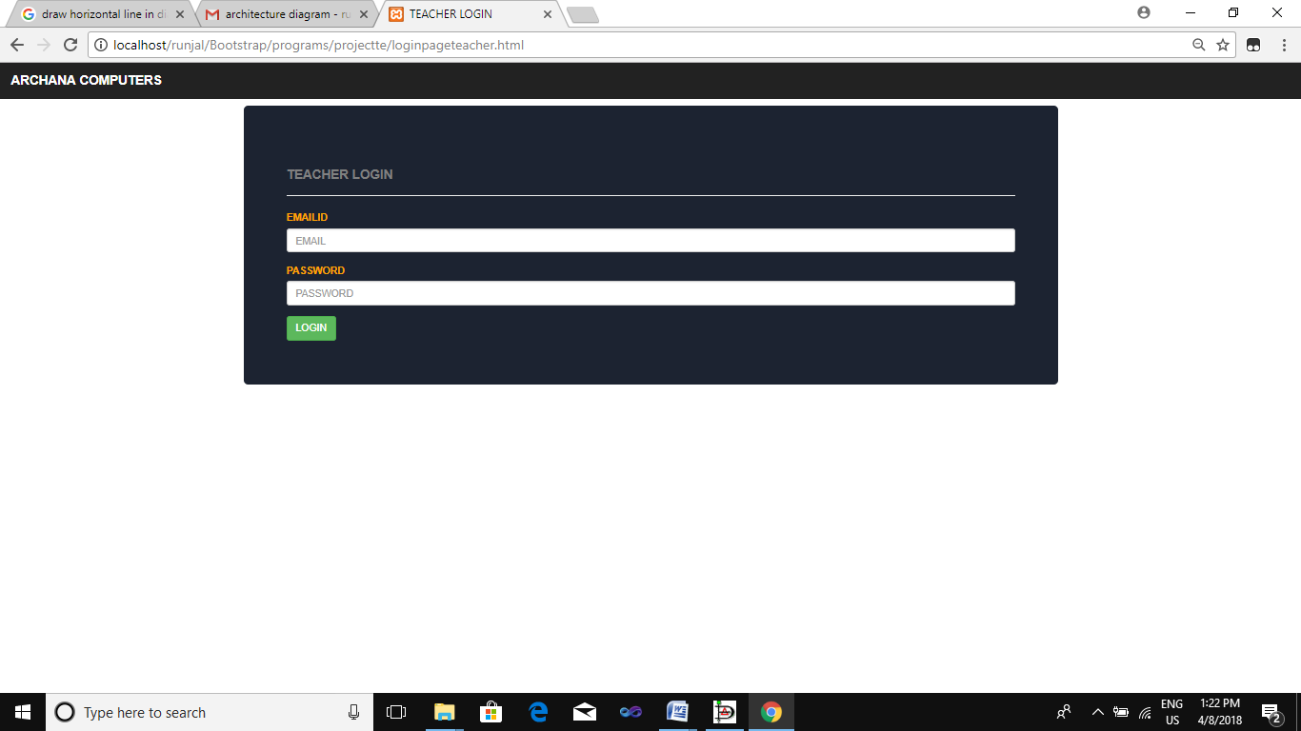

Fig e:Teacher Login Page

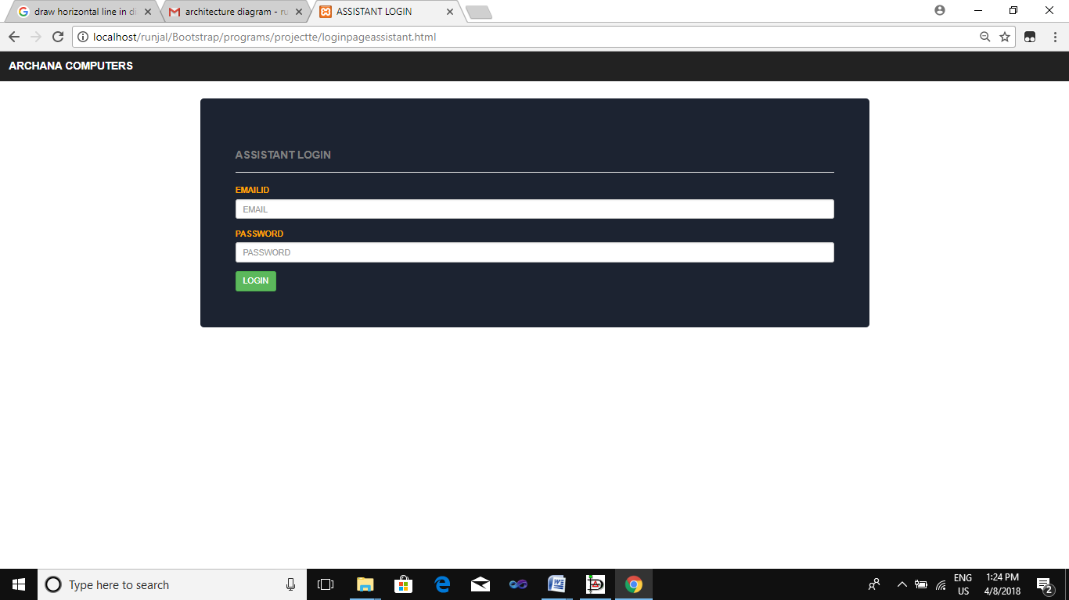

Fig f: Assistant Login page

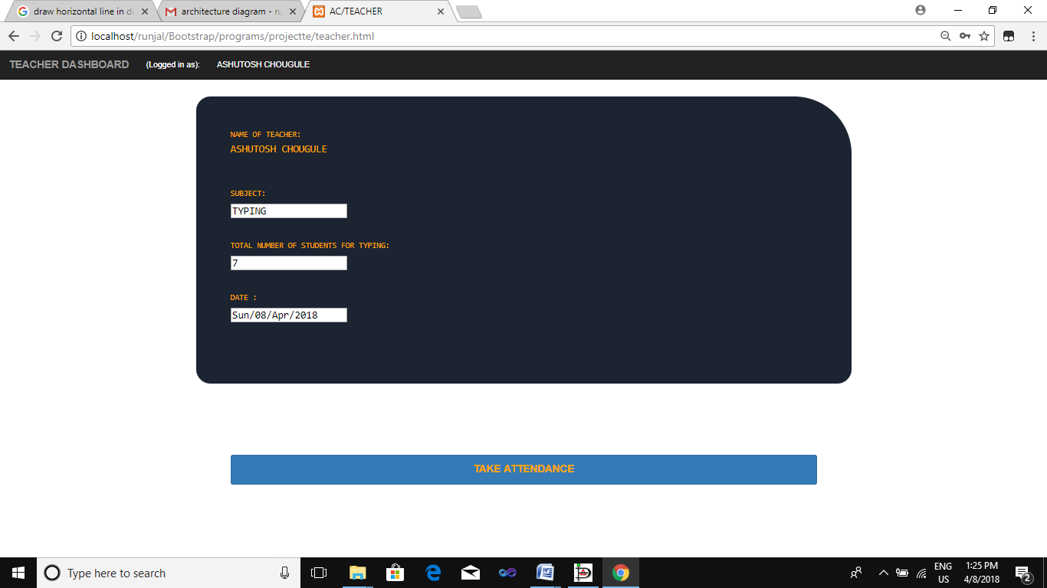

Fig f: Attendance Page

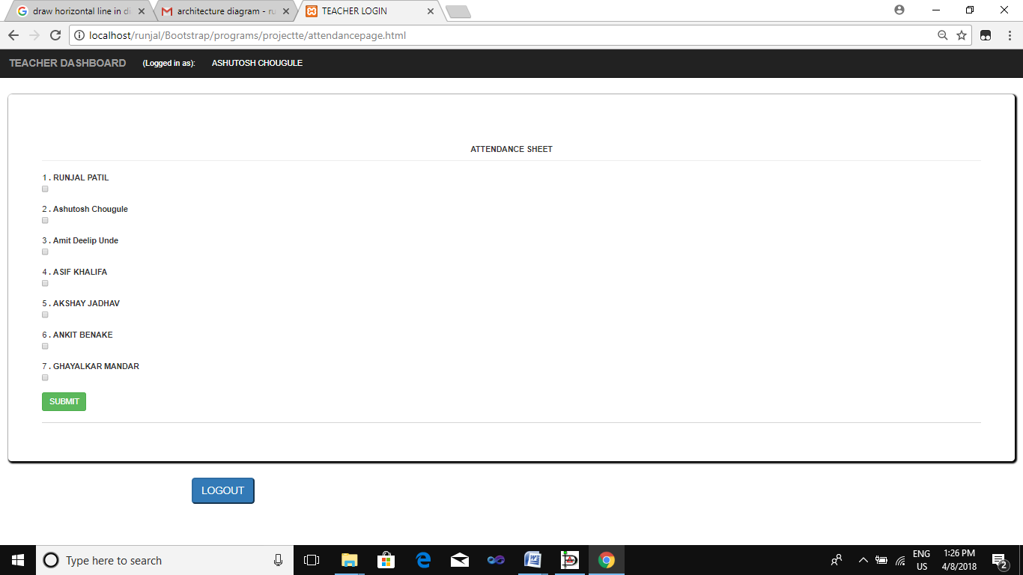

Fig h:Attendance sheet

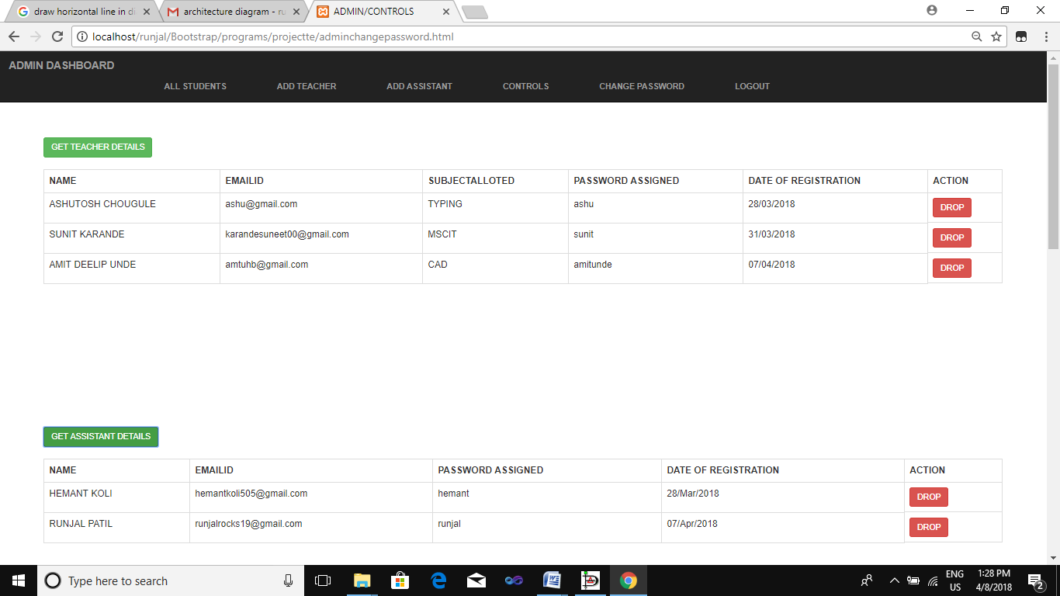

Fig i: Admin Panel(control page)

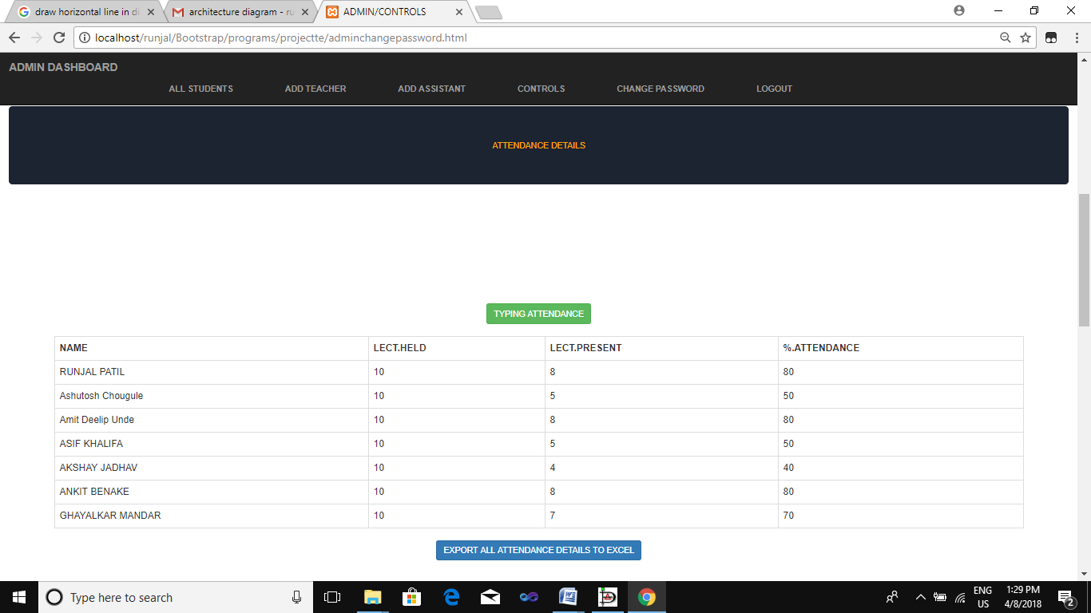

Fig g: Attendance Details(Control page)

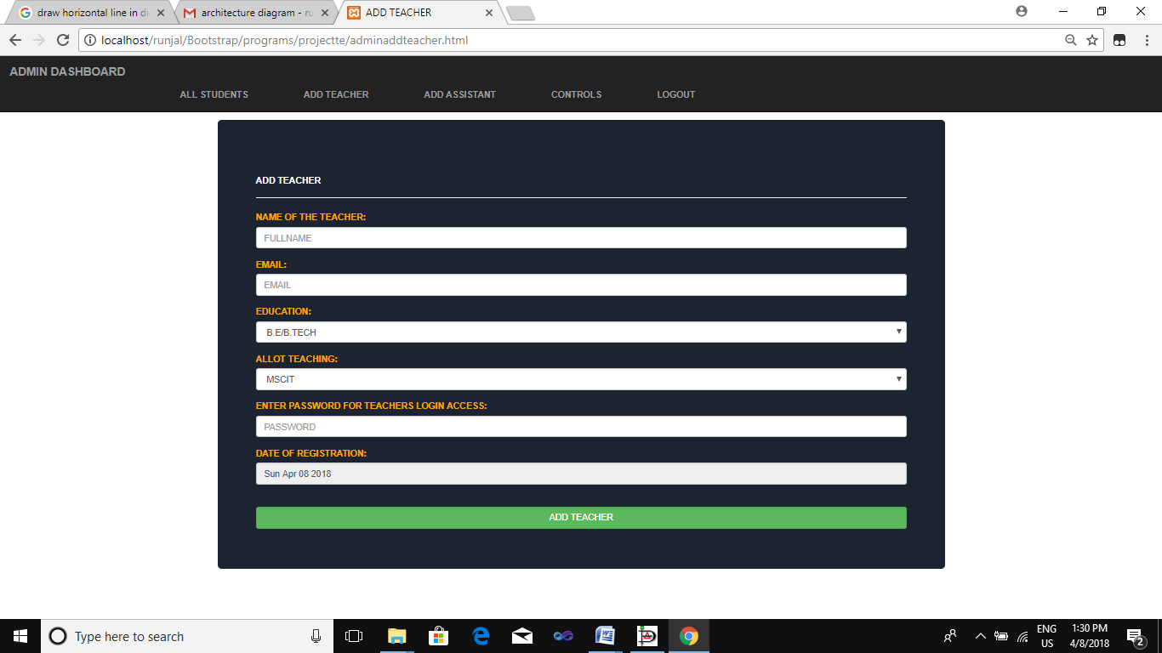

Fig x:Add Teacher (Admin Dashboard)

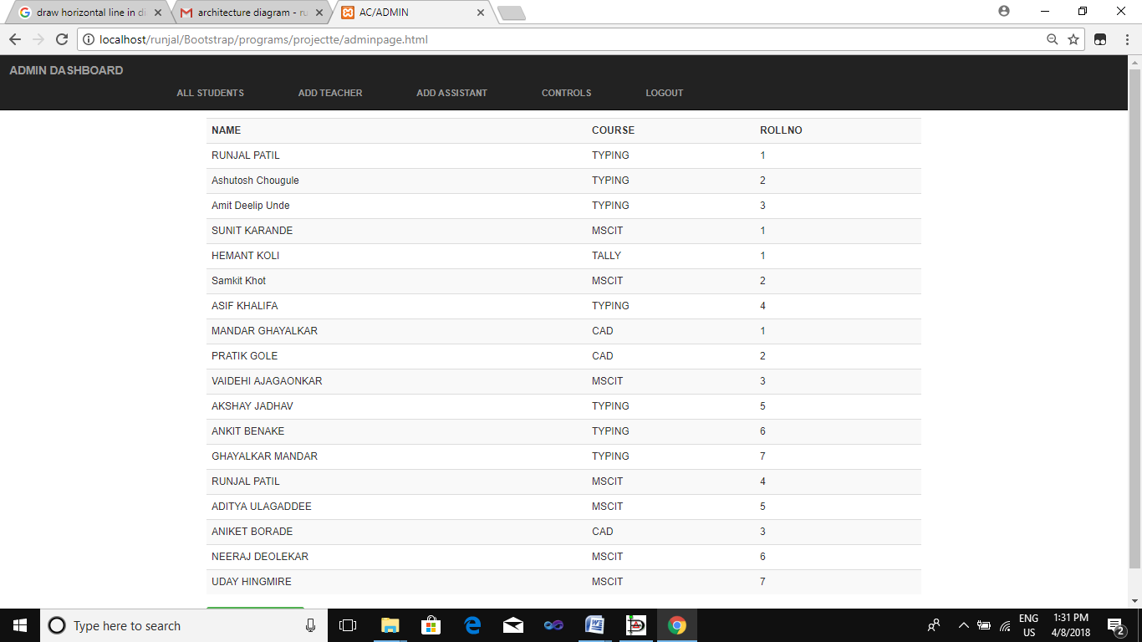

Fig y: Registered Students List

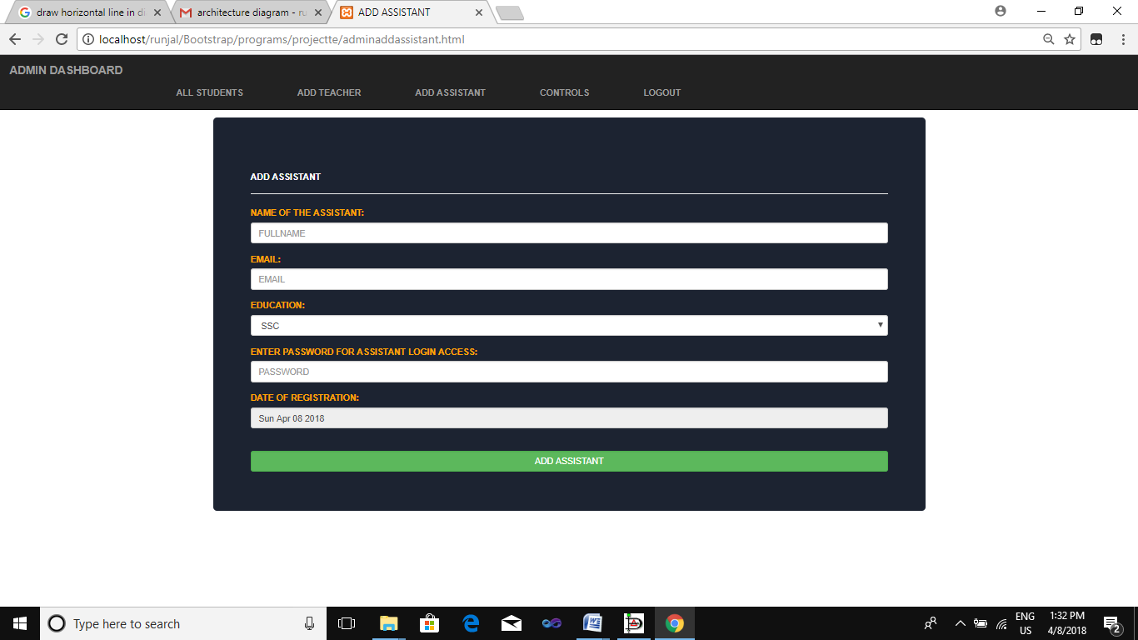

Fig j:Add assistant(Admin dashborad)

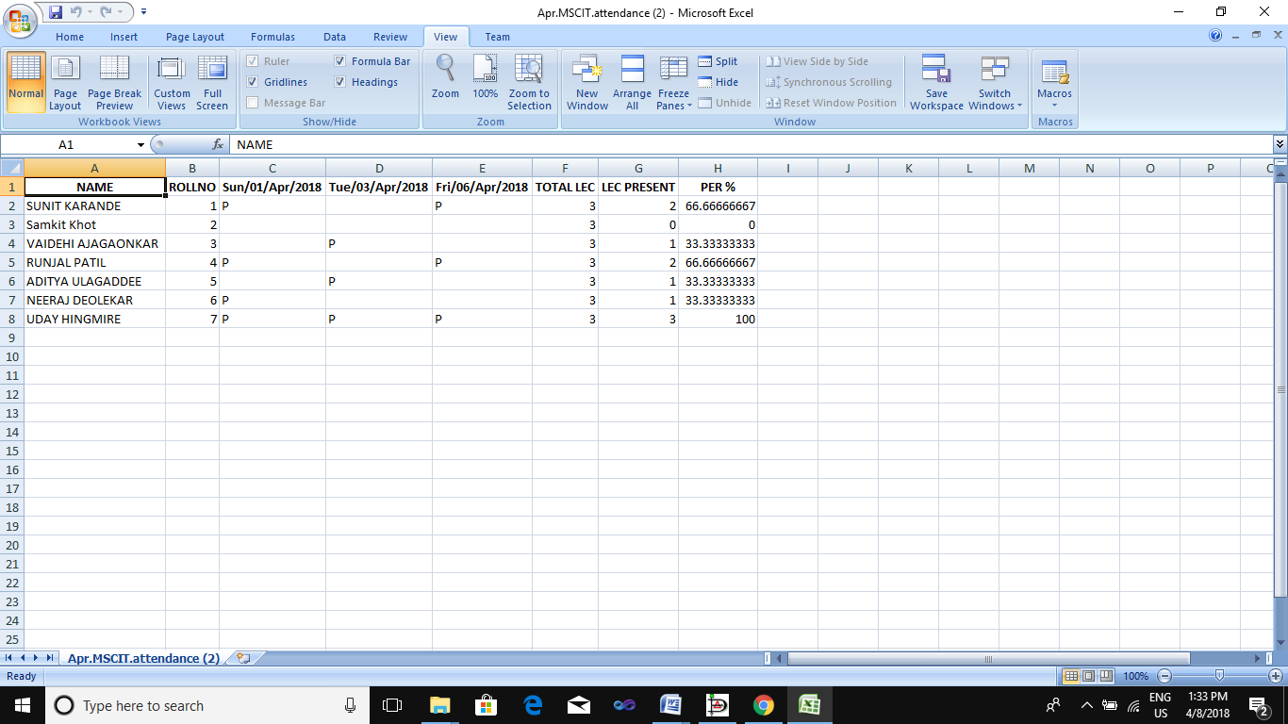

Fig k: Monthly Attendance in Excel Fo.

**9. Future Work**

In the future work there are some features we would like to add in our project.We can add student module to see the attendance of student personally.We can add the edit option in the attendance sheet to edit the attendance of that day

**10. Conclusion**

In our project we learnt how to develop website. For doing this website we understood the use of database and how to store, retrieve ,delete, update the values in database. Also we learnt how to design the website using html, css, bootstrap and JavaScript.

**REFERENCES**

**Books:**

1. HTML and CSS: Design and Build Websites.
2. Learning Web Design: A Beginner’s Guide.
3. Designing with Web Standards.

**Websites:**

1) [www.redcrossblood.org](http://www.redcrossblood.org)

2) [www.donateblood.com](http://www.donateblood.com)

3)[www.slideshare.net](http://www.slideshare.net)

4) <https://www.scribd.com/doc/306746711/Blood-Bank-Management-> System Project-Report